5. Parameters in CloudFormation:

* Using the Parameters section is optional in cfn templates
* It is used to customize the templates.
* Parameters enable you to input custom values to the template

Syntax:

Parameters:

ParameterLogicalID:

Type: DataType

ParameterProperty: value

Only Type is Mandatory:

All other properties are optional / might be required based on other properties

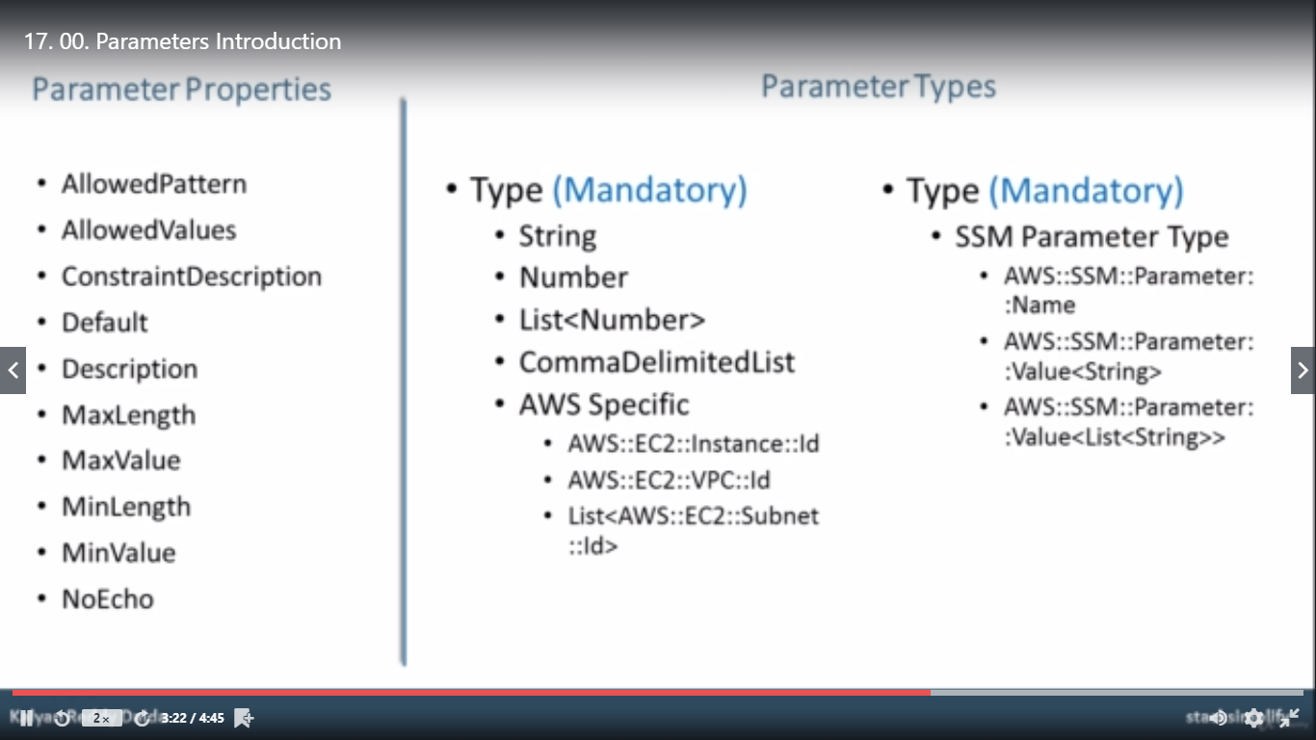

Example:

Parameters:

InstanceTypeParameter:

Type: String

Default: t2.micro

AllowedValues:

- t2.micro

- m1.small

- m1.large

Description: Enter t2.micro, m1.small, or m1.large. Default is t2.micro.

## Refer the Example Yaml files.